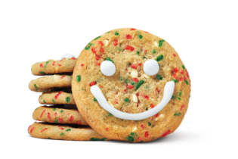
Pre-Order Form
From November 13-19,2023
Spruce Grove Tim Hortons Restaurants
will be supporting
Parkland Food Bank Society
Gather your family, friends, colleagues and teams!

To pre-order Tim Hortons Holiday Smile Cookies, complete this form and submit it to the Parkland Food Bank Society at sheri@parklandfoodbank.org less than 48 hours prior to your pickup. This will enable us the time to ensure your order is fresh and ready!

Cookies are $1.50 each – Box of 12 is $18
Number of Boxes: |  | 12 Cookies per box

Your Name:
Address:
 | Telephone: | ( )
 | Email:

Pick Up Date and Location: |  | Pick Up Time:

Thank you for your support!
Parkland Food Bank Society is driven by the belief that a well-fed community is a stronger and more resilient community. We invite you to join us in making a difference by supporting our efforts to combat hunger, empower individuals, and build a brighter future for all. Together, we can nourish hope and strengthen our community.
